Group Project Plan

# 一、Assessment

1. Project website
2. Interim group report
3. Final group report
4. Individual report
5. Software & documentation
6. Demonstration
7. Presentation
8. Promotional digital artefact
9. Peer assessment

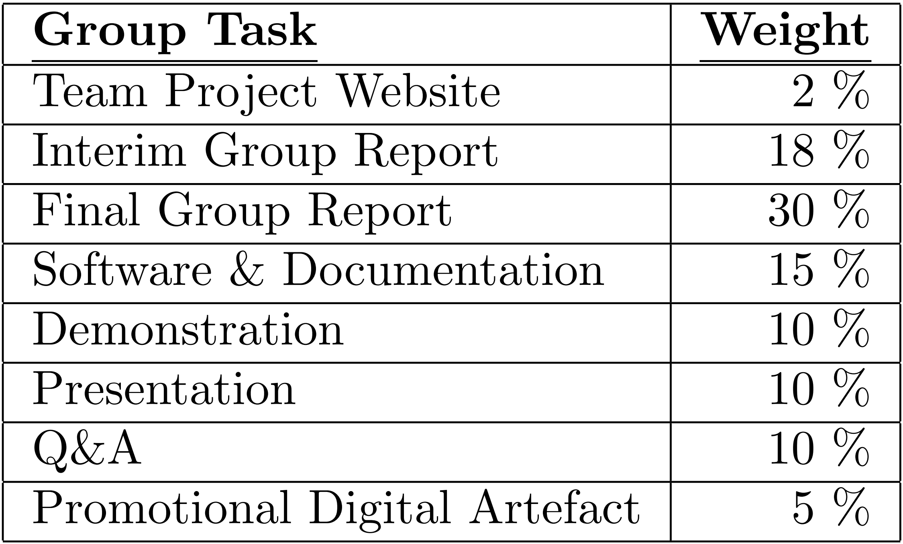

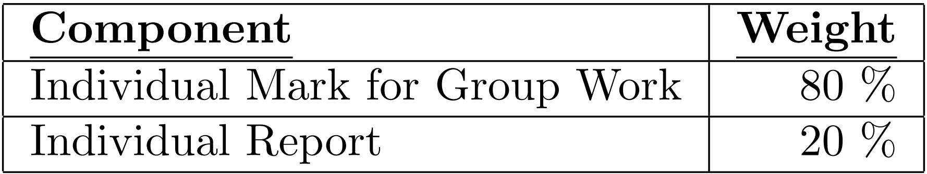

评分细则：

Exceptional: utmost systematic and professional manner

a problem analysis and subsequent requirements specification of stunning clarity and insight

问题和需求分析异常清晰在理

a system design of highest possible quality, meets all requirements, given at a level of precision and detail that directly could be translated into an implementation

系统设计质量超高，符合所有需求，精准，精细，可以直接被实现

an implementation of highest possible quality and completeness whose conformance to the original specification has been verified rigorously

实现的质量超高，完成度能够被严格得和需求相对应，有良好的comment，易于理解

impeccable project management in terms of planning, workload management, meeting deadlines, making the best possible use of each team-member’s skills and strengths, and with absolutely minimal (technical or otherwise) guidance from the supervisor

无可挑剔的项目管理，无论是计划，工作负担分配，deadline，最大限度上利用好每个人的技能和优势，最少的外界帮助

**其中,**

Assessed aspects of the submitted **software** include, but are not limited to:

• Functionality and features

• How well the developed software actually works

• The size and difficulty level of the addressed problem(s)

• The technical sophistication of the developed software

• How well the software is written (architecture, proper modularisation, proper abstractions, naming conventions, layout, documentation, etc.)

• Quality of the testing

也包括Report 中的testing，open day展示，markers的测试，presentation

Appropriate **documentation** for a (potential) maintenance team should be submitted, which may include:

• Summary of quality assurance

• Environment requirements (operating system, hardware, etc.)

• Installation instructions

• User manual

Excellent:

The reports and software should display a complete and thorough understanding of the conceptual and practical issues surrounding the project topic, including related work.

报告和软件应当围绕项目的理念和实现呈现完整完善的理解，有清晰的结构和强有力的论证与分析

There should be evidence of a high degree of testing

高级别的testing工作

Supporting documentation should be complete and approaching the standard of high quality professional documentation

高质量的标准的专业documentation，完整的，良好呈现和叙述的

# 二、Content

1. Technically: engineering requirements, system architecture and design, user interface design, implementing a medium sized, multi-component system, systematic testing and debugging, programming in a team, and use of software engineering tools
2. Other: running meetings, making collective decisions, time and people management, writing reports, giving presentations, interpersonal skills, and resolving conflicts

其中，成员角色确定handbook上有指示：Team Leader, Chief System Architect, Repository Maintainer, Lead Programmer, or Lead GUI Designer

最新文件指示：Motivator (initiator), Idea generator, Team worker (“getting the job done”) , Specialist (technical, writing, . . . ), Coordinator (administrator) , Censor (devil’s advocate), Mediator (supporter, mentor), Monitor (tester), Completer-finisher, Editor, Technical Lead, Quality Assurance Lead, Repository Master, UI Designer, Open Day Producer

**Team leader**: Overall planning and coordination, Motivator, Arbiter, Main point of contact

**Editor**: Document structure, Layout (creates templates), Structure of writing process (e.g. draft deadlines, organisation of proof reading), Integration of contributions

**Technical Lead**: System architect, Identify key technical choices, pros and cons, Lead programmer (as projects are not too large)

**Quality Assurance Lead**: Making sure requirements are testable, Planning for quality assurance, in particular testing, Writing test cases, Automation of testing, in particular regression testing

**Repository master**: Overall responsibility for managing project site and repository, Training everyone in how to use the site and associated tools, Project website deadline

Meeting一周两次，chairperson和secretary轮流当

1. Overall timeline

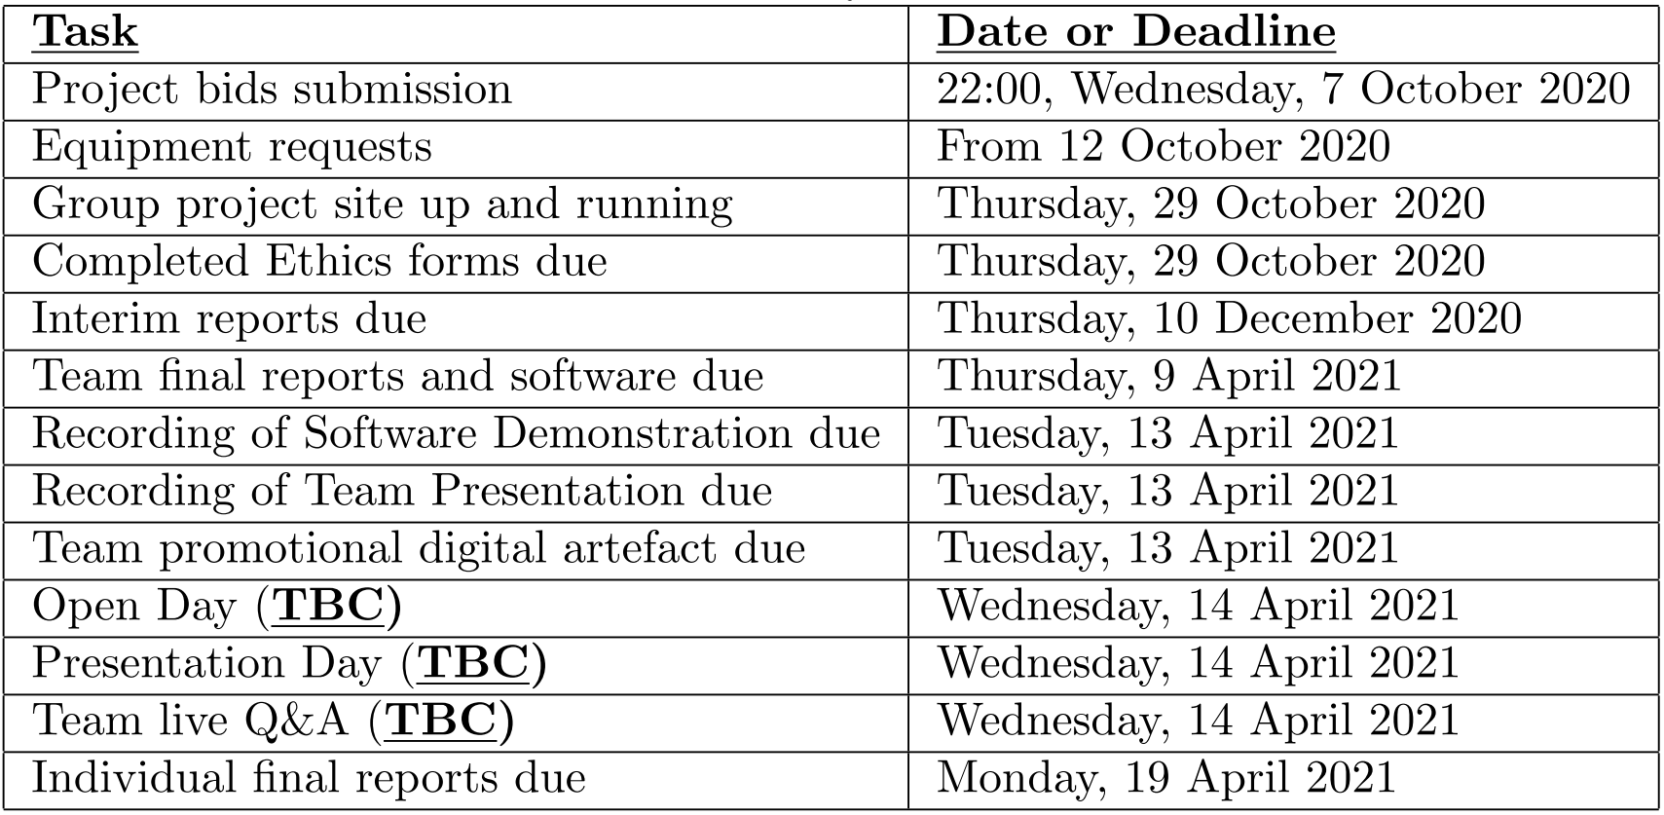

# 三、人员分配

|  |  |
| --- | --- |
| 陈诗量 | Leader, technical leader, |
| 韩睿孜 | Report editor, repo master, |
| 黄雅妮 | UI designer, monitor, mediator |
| 卢艺捷 | Quality assurance leader, monitor |
| 姜宇婷 | Quality assurance leader, report editor, |
| 唐懿明 | UI designer, repo master |

o Balance of member skills

o Clear goals

o Clear responsibilities

o Good organisation

o Good communication, including listening

o Commitment to goals: willingness to put group goals before ego and/or comfort

o Mutual respect and valuing

# 四、Group timeline

9/23-9/25

熟悉handbook，知道GRP需要做些什么

仔细阅读catalogue，确定自己感兴趣的三个项目，并附上理由，完成自己的project bids

准备星期五的第一个Group meeting，准备自我介绍和确定自己擅长的领域

9/25

组内项目选择，根据所有人的bids介绍，选择合适的最多三个项（注意catalogue中的项目仅为potential projects）

分配组员角色

讨论bid中可以写到的让我们中标的东西

讨论提高效率和管理方式

10/5

Bid初稿上传，格式为Team.2020.10.<PreferenceNumber>.<ProjectID>.zip

10/7 20:00

检查已上传bid文件，格式为

Team.2020.10.<PreferenceNumber>.<ProjectID>.zip

10/8

开始分配group page制作

# 五、Meeting Record

Informal meetings:

coordination and getting some real work done

Organisational matters

Design discussions

Discussions about specific technical problems

Reviews and inspections

Formal meetings:

Formally monitor progress by reviewing minutes from preceding formal meeting

Formally take major design decisions

Formally decide on what should be done over the next week, and who is responsible

Keep supervisor informed about where the project is going

Seek input from supervisor

Discuss problems

Structure of formal meeting:

Progress review: be sure to follow up on all outstanding action points

Review of old action points and other discussion will generate further action points. Record them (e.g. on white board)

Be sure to review all new action points towards the end of meeting to ensure everyone knows and understands what their tasks are

1. 活跃的群氛围，

2. 可以有企业微信

3.共享空间，github，gitlab

4.记录今日所做，帮助个人report

5. 工作报告，黄雅妮模板

6. bid所需要的cv和项目经历，黄雅妮准备格式

7. 选择四到五个留后路

8. 会议记录 轮流

1 5 6

9 人脸识别，实用性和可行性高，但是选的人多

12 水资源预测和管理

16 交通检测系统 实用性和可行性高

18 选择的人多可能不如其他组可行性搞

9/28

30号交cv 团队经历

3号交bid

# 六、Bid Part

• A letter outlining why the team is a good candidate for completing the project

解释我们组为什么好，为什么合适

• Details of relevant experience or expertise. Some teams may like to include CVs or resum´es for their team members

经验和专业上的细节，附上简历

• Some proposed ideas related to the project

有什么自己独到的见解

• An estimated timeline or schedule for how the team would complete the project on time

预估的计划和时间线

An expression of interest (EoI) for the project

使用模版写兴趣点

* Motivate why the team is bidding for the project and wants to work with the sponsor,
* demonstrate some level of understanding of the problem and its context,
* demonstrate technical understanding and illustrate that the team has the necessary skills to carry out the project,
* give an understanding of how the project will be managed,
* be tailored to the project and honest on what the team can offer.

A pitch to the sponsor and supervisor of the project.

向负责人推销

* Contain short introductions of the team members, their roles within the team, and how the project will benefit from members’ backgrounds (technical and soft skills),
* have all members of the team involved in the pitch acting as a united team,
* have relevant content, mockup models, a workplan, work packages, and propose milestones,
* explain project management approach that will be used,
* be tailored to the brief, well structured, supported by slides, visuals, and animations,
* be engaging, interactive, professional, and enthusiastic, whilst demonstrating ambition and realism,
* give strong and concise answers to questions,
* contain conclusions and a final summary.

# 七、Interim Group Report 12/10

4000-5000 words

• Updated and expanded description of the **problem to be solved**.

• **Background** information and **research** such as

– survey of any **existing systems** that address similar problems

– results of any **market research** conducted

– results of **technical research** into suitable platforms, tools, technologies, algorithms, data structures, etc.

• **Requirements specification** for the system to be built (agreed between the team and supervisor).

• **Initial design** of the proposed system and its **user interface**.

• Record of key **implementation decisions**, such as programming languages, operating systems, computers, and any additional software and hardware to be used, along with reasons for those decisions.

• Results of any **initial** implementation steps/prototyping.

• Discussion of **any problems encountered** so far, including both technical issues and management issues, like group working etc.

• **Time plan** for the project.

• Minutes from the **meetings** held to date, included as an appendix.

One printed copy of the interim group report should be submitted as well as an electronic copy in PDF format. The front page of the report should include:

• The text “COMP2043.GRP Interim Group Report”

• Project title

• Date

• Team name/identifier

• Names and School of CS usernames of all group members

• Name of supervisor

# 八、Final Group Report 4/9

7000-8000 words, a **self-contained**, updated, and expanded version of the Interim Group Report

• Updated design of the system and its user interface.

• Discussion on the implementation and testing of the system. This must include a list of all major system components, which of these were written by the group and where the others come from, and an overview of the developed source code hierarchy.

• Summary of what was achieved, referring to the stated requirements.

• Reflective comments on the success of the project, both from a technical and a project management perspective, including group working issues etc.

• An appendix giving a description of how the developed system was tested (test cases, example outcomes, etc.)

• Minutes: Minutes from all formal meetings should be submitted as an appendix.

• A user-manual (if appropriate) should be included as an appendix. Excerpts of the developed code can be included in the report for illustrative purposes, but any lengthy excerpts should go into the appendices.

The front page of the report should include:

• The text “COMP2043.GRP Final Group Report”

• Project title

• Date

• Team name/identifier

• Names and School of CS usernames of all group members

• Name of supervisor

# 九、Submission of Software and Documentation

The code should be submitted either in the form of a zip archive or a gzipped tar archive of the entire source code hierarchy.

if feasible, it is good if what is submitted is complete and if instructions for how to run the system are included.

**All source code should be properly attributed.** (e.g. by a comment at the top of each file)

Any system components not written by the team (e.g. libraries beyond standard libraries) must be properly identified.

Any software licenses that apply to third-party components must be followed and be compatible with the project.

评分细则见第一部分

# 十、Individual Report

2000-2500 words, individual report must include the peer assessment as an

appendix

• Summary of own individual contribution to the project.

• Reflection on the project, the running of it, and own role within it, including honest and insightful self-assessment.

The reflection should cover aspects such as what was achieved, what was

not achieved and why, critical discussion on the running of the project, what you have learnt from the project, and what you would do differently if you were starting over again.

• Peer assessment.

Note: that Individual Report is marked primarily on the quality of the reflection and on the qualities as a report, not on the extent of contribution as such to the project

• The text “COMP2043.GRP Individual Report”

• Project title

• Date

• Team name/identifier

• Your own name and School of CS username

• A list, clearly labelled “other group members” of the other members of the group

• Name of supervisor

# 十一、Team Project Website

It is marked very simply based on **having the necessary information** available by the first deadline

by having updated relevant information throughout the duration of the project

• Team name

• Project title

• Supervisor name

• Any other relevant information (such as links or explanation or technical details).

# 十二、Golden Rules

Work consistently throughout the project

Make sure that you have enough to do

Don’t leave the programming until too late

Do use proper tools to avoid wasting time and effort

Don’t think that you can do the write up in just a few days

Take the meetings seriously

Keep good records of your meetings